Chapter 7: Forces

7.1 A force is a push or pull

Student worksheet answers (pages 120–121)

Push and pull forces

1 Forces act on everything around us all the time. Although these forces cannot be seen, their effect can be observed. In the spaces provided, draw a labelled diagram to explain what forces cause objects to do. (Use a different example from the ones in the textbook.)

**Begins to move**

Student responses will vary but could include pushing a chair under a desk.

**Speeds up**

Student responses will vary but could include changing from a jog to a sprint.

**Slows down**

Student responses will vary but could include using the brakes on a car.

**Changes direction**

Student responses will vary but could include a cricket batsman hitting the ball.

**Changes shape**

Student responses will vary but could include bending a paper clip.

**Remains still**

Student responses will vary but could include a statue.

2 Write the definitions for the following words to help you revise some terms that you have encountered in previous chapter and also revise the new words:

a Force

A force is a push or pull on an object to change its motion

b Gravity

Gravity is the force of attraction between objects.

c Spring balance

A spring balance is a device that can be used to measure force.

d Calibrated

To calibrate an instrument is to check its accuracy against known measurements. Thus, if something is calibrated, its accuracy has been established.

e Newton

A newton is the unit used to measure force.

EXTEND YOUR UNDERSTANDING

3 Research the forces involved in one of your favourite sports (e.g. kicking a football in AFL or stopping suddenly in netball).

Student responses will vary depending on the sport they have chosen to research. Forces could include those that act on the body (joints, bones, muscles etc.) and on the equipment used (footwear, bats, racquets, ball, padding etc.).

7.2 An unbalanced force causes change

Student worksheet answers (pages 122–123)

Balanced and unbalanced forces

Force diagrams can be used to represent the direction and strength of a force. A short arrow shows a weak force, whereas a long arrow indicates a strong force.

1 The diagrams below show the force acting on a block. Beside each diagram, write whether the force is *balanced* or *unbalanced.*

a Balanced

b Unbalanced

c Unbalanced

The direction of the force can also be determined by looking at the length of the arrows and the direction the arrow is pointing.

2 The diagrams below show the force acting on a block. Under each diagram, draw an arrow to indicate the direction that the block would travel.

a ←

b →

c ←

The net force can also be worked out by looking the length and direction of the arrows and the newtons of force. If the forces are in the *same* direction, they can be added together. If the forces are in *opposite* directions, they can be subtracted.

3 The diagrams below show the force acting on a block. Under each diagram, draw an arrow to indicate the direction the block would travel and calculate the amount of force (in newtons) acting on the object.

a →, Net force = 9 N

b →, Net force = 1 N

c →, Net force = 6 N

EXTEND YOUR UNDERSTANDING

4 Investigate a place you know (e.g. your home or a relative’s house). Write five examples of unbalanced forces that you experience at this location.

Student responses will vary depending on their location. Examples could include opening a door, closing cupboards, opening a lid, etc.

7.3 Forces can be contact or non-contact

Student worksheet answers (pages 124–125)

Magnetic force

1 Magnets are an example of a non-contact force. What does this mean?

This means that magnets produce an invisible push or pull force between themselves and another magnetic object.

2

a Magnets are made of an alloy. What is an alloy?

An alloy is a mixture of two or more metals

b The main metal in most magnetic alloys is iron.

3 On each of the diagrams below, write if the force between the magnets is an *attraction* or a *repulsion*. Include an arrow to indicate the direction of the force.

Attraction

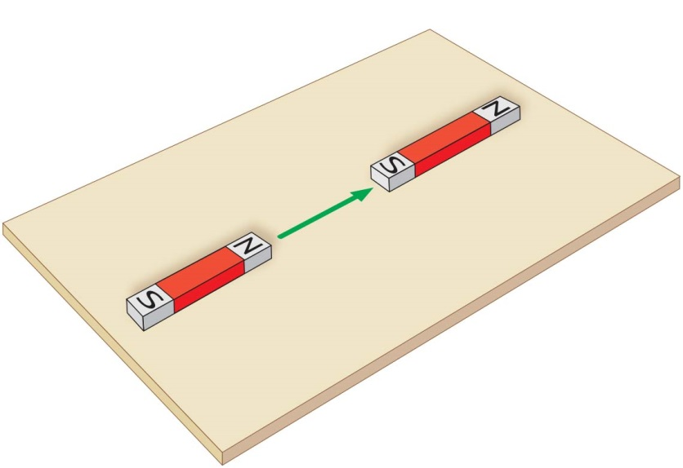

Repulsion

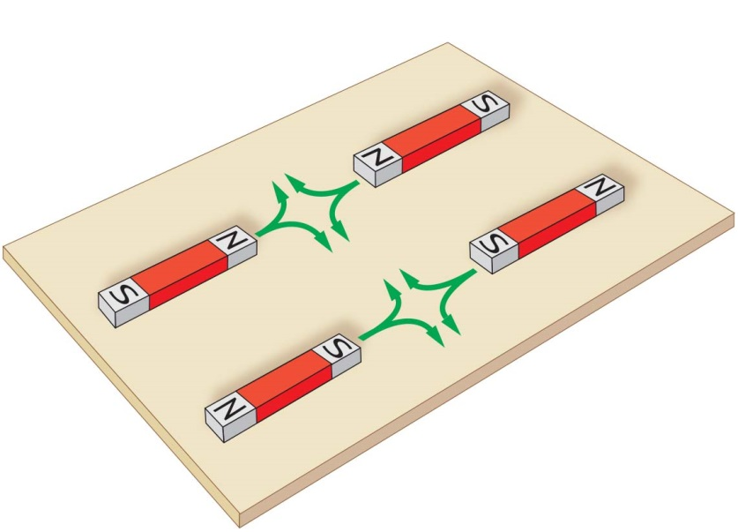

EXTEND YOUR UNDERSTANDING

4 Find out about another four possible applications of Maglev technology.

Student responses will vary but could include:

• frictionless wind turbines

• the study of weightlessness on humans

• magnetic bearings in machines, floating cities or flying cars.

7.4 Magnetic fields can apply a force from a distance

Student worksheet answers (pages 126–127)

Magnetic fields

1 Magnetic fields can be shown by scattering iron filings around a bar magnet.

a Why are iron filings used to show magnetic fields?

Iron filings are used because they are magnetic (and so are attracted to the magnetic fields) and very small or fine.

b Magnetic field lines should point away from the north and towards the south. Draw a map of the magnetic field lines on the second magnet.

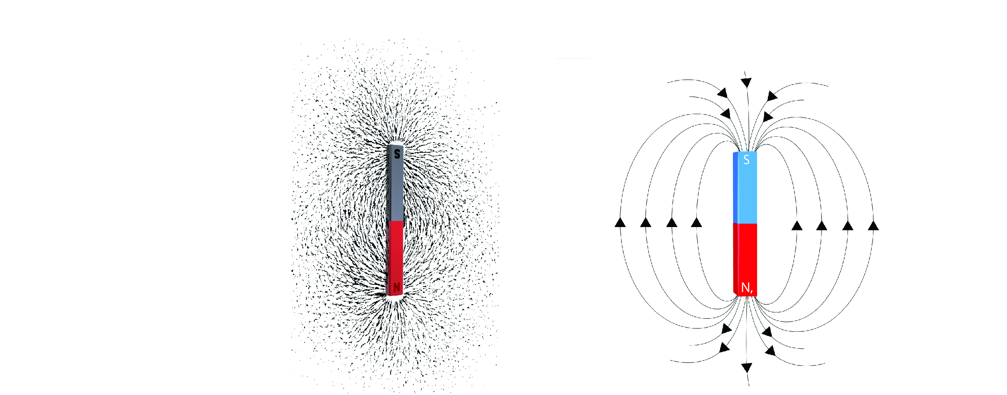

c Draw a map of the magnetic field lines on the magnet below.

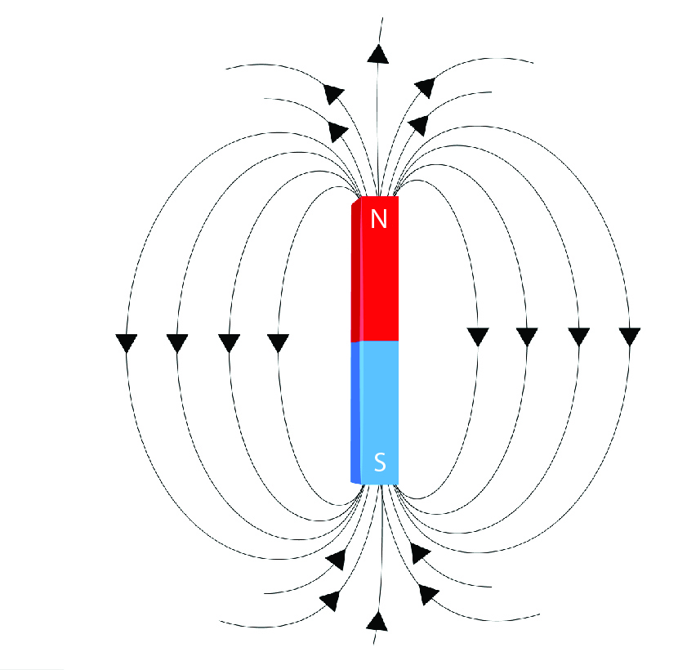

2 The Earth is like an enormous magnet with its own north and south poles.

a What is the difference between the Earth’s magnetic pole and the Earth’s geographic pole?

The magnetic poles are not fixed points: they move according to the magnetic field of the Earth. The geographic poles are fixed locations.

b Draw magnetic field lines on the diagram of the Earth below.

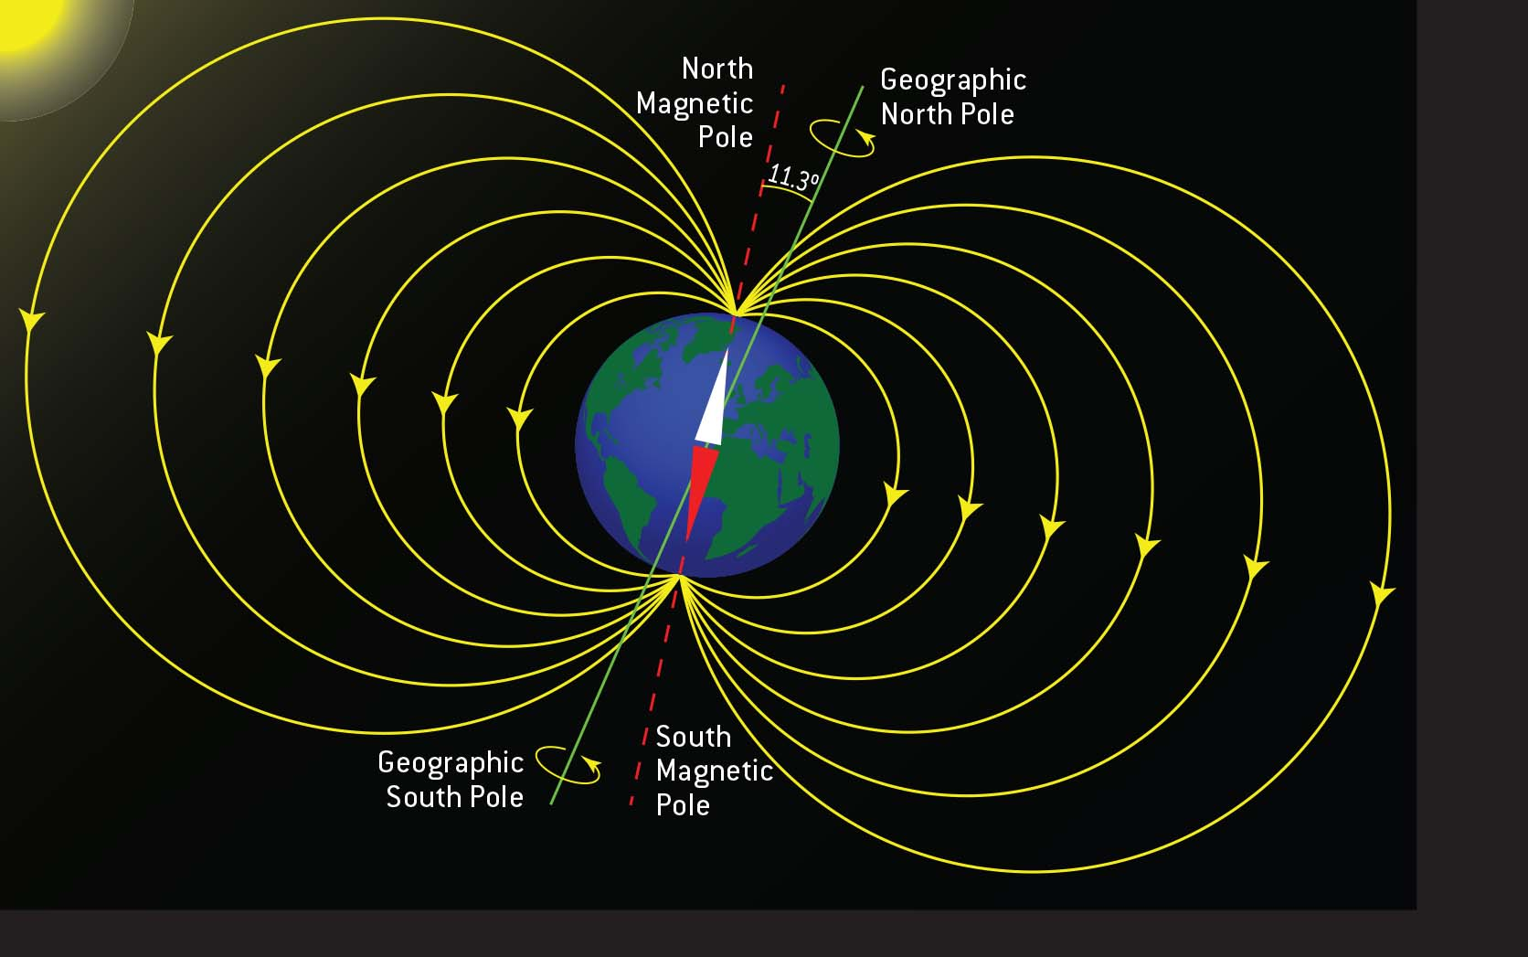

EXTEND YOUR UNDERSTANDING

3 The Earth’s magnetic fields affect various natural phenomena, from turtles navigating their way through the ocean to the majestic light show of the auroras. Research another animal that uses magnetic fields to help it navigate or find out more about the formation of the auroras.

Student responses will vary depending on the animal chosen or whether the formation of auroras was chosen. Other animals that use magnetic fields for navigation include pigeons, whales, and bats. Auroras form as a result of collisions between charged particles emitted from the Sun during a solar flare and atoms and molecules in the Earth's atmosphere that create bursts of light that make up the aurora.

7.5 Electrostatic forces are non-contact forces

Student worksheet answers (pages 128–129)

Static electricity

1 In each of the scenarios below, write whether the objects will *attract, repel* or *do neither*.

a Two negatively charge objects:

repel

b Two positively charged objects:

repel

c A positively charged object and a negatively charged object:

attract

d A positively charged object and a neutral object:

attract

e A negatively charged object and a neutral object:

attract

f Two neutral objects:

do neither

2 Complete the following sentence about the creation of electrostatic charges.

When objects are rubbed they become charged because they have lost or gained negative charges or electrons.

If they are placed near neutral objects (which have equal or balanced positive and negative charges) they will be attracted to the positive charges and will move towards that object.

This attraction or electrostatic force due to charges is called static electricity.

3 In the space on the following page, draw a simple sketch to show what you would look like if you were touching a Van de Graaff generator.

a Add labels to the diagram to answer the following questions:

i Where do the charges come from that build-up on the dome?

ii Why are the charges attracted to nearby objects?

iii What causes your hair to stand up on end?

iv Why would you need to stand on a rubber mat?

The diagram should be a self-portrait (simple to complex depending on the student’s artistic ability) and should show their hair standing on end.

Charges on the dome come from the build up of static electricity.

These negative charges are attracted to neutral objects because of electrostatic force.

Hair stands on end because each hair has a negative charge, therefore repels.

Rubber is an insulator, which stops the flow of electrons (negative charges) going into the ground.

EXTEND YOUR UNDERSTANDING

4 Research who invented the Van de Graaff generator. Write a short biography of the inventor and find out whether the inventor made any other discoveries.

The Van de Graaff generators were designed and constructed by Robert Jemison Van de Graaff (1901–1967), an American physicist. During World War II, Van de Graaff was the director of the High Voltage Radiographic Project; after WWII he co-founded the High Voltage Engineering Corporation (HVEC) with John G. Trump, Donald Trump’s uncle. Van de Graaff also developed the insulating-core transformer, which produces high-voltage direct current, tandem generator technology and electrostatic accelerators.

7.6 Friction slows down moving objects

Student worksheet answers (pages 130–131)

Friction

1 Fill in the gaps to complete this summary of friction:

Friction is a contact force. It works when the surface of one object rubs against the surface of another object. The greater the area of contact between surfaces, the greater the friction. Friction acts in the opposite direction to movement. The smoother (or rougher) the surface, the less (or more) friction there is and the more (or less) an object can move. Friction can generate heat when objects are moving: the greater the friction, the greater the heat made.

2 Describe a situation when there is too much friction.

Student responses will vary but should include a situation where heat, reduced movement or wear occur, such as in the case of an ungreased bicycle chain.

3 Describe a situation when there is too little friction.

Student responses will vary but could include slipping on an icy or wet surface.

4 Study the diagrams of different surfaces. Rank the surfaces from 1 (least frictional force) to 4 (least frictional force).

Carpet: 3

Rocks: 4

Ice: 1

Wet grass: 2

5 Explain two different methods you could use that would allow you to *push* a heavy boulder across the ground.

Student responses will vary but should include methods to reduce friction, such as lubricating the boulder or the ground and putting wheels or rollers under the boulder, and applying more force (e.g. using more people to push or pull the boulder).

6 Using the concept of friction, why is it useful that we produce saliva as we chew our food?

Saliva reduces the friction between the food and our teeth, reducing the wear on our teeth. Saliva also lubricates the food, making it easier for us to swallow.

EXTEND YOUR UNDERSTANDING

7 The device pictured here is a perpetual motion machine. Using your understanding of friction combined with research from the Internet, explain whether this machine is possible.

Students should discover that a perpetual motion machine is impossible to ever achieve because of friction, which is always present on Earth, and other sources of energy loss.

7.7 Simple machines decrease the amount of effort needed to do work

Student worksheet answers (pages 132–133)

Simple machines

1 The three images below show the methods the Egyptians used. For each image, identify the simple machine used and discuss how this machine was used to increase the amount of force.

a A rope is a simple machine that has been used to pull the block of stone. Students may also refer to the trebuchet, which could be used to raise the blocks like a modern-day crane. Students may also just notice the log under the block, which would roll to reduce friction.

b Levers and ropes have been used to move the large block. Wedges would have also been used to create a gap for the levers.

c Levers, wheels and ropes have all been used to move the heavy block.

2 Levers allow us to lift and move loads that are heavier than we could actually pick up using just our body. Below are diagrams of the three classes of lever. For each diagram:

• identify the class of the lever

• label the fulcrum, load and the direction of the effort

• draw an example (different from those in the textbook) of this type of lever.

a

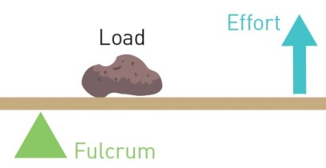

This is a second-class lever. Students may provide different examples of second-class levers, but one example is a see-saw.

b

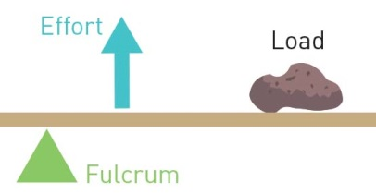

This is a third-class lever. Students may provide different examples of third-class levers, but one example is a bottle opener.

c

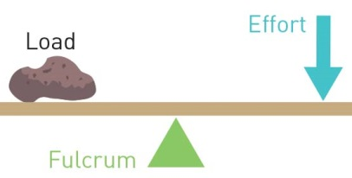

This is a first-class lever. Students may provide different examples of first-class levers, but one example is a pair of tweezers.

3 Because levers allow people to lift and move heavy loads, they give people a ‘mechanical advantage’. The mechanical advantage can be calculated by dividing the size of the load (in newtons) by the size of the effort (in newtons). For example, if a wheelbarrow contains a 3 N load and it requires 1 N of effort to lift, the mechanical advantage is 3 divided by 1, which equals 3. Work out the mechanical advantage in the following situations:

a A boulder has a 10 N load and requires 5 N of effort to move it using a lever. What is the mechanical advantage of the lever?

Mechanical advantage = 10 ÷ 5 = 2 N

b A nail had a 9 N load of resistance and requires 3 N of effort using a hammer to remove it. What is the mechanical advantage of the hammer?

Mechanical advantage = 9 ÷ 3 = 3 N

c A washing machine has a 600 N load and requires 200 N of effort to move it using a trolley. What is the mechanical advantage of the trolley?

Mechanical advantage = 600 ÷ 200 = 3 N

EXTEND YOUR UNDERSTANDING

4 Research some of the simple machines that were used by the Ancient Romans or Greeks during the construction of their societies. Try to find an example of a first-, second- and third-class lever used by these societies.

Student responses will vary depending on the depth of research and choice of machines. Examples include Ancient Greek technology developed during the 5th century bce, continuing up to and including the Roman period and beyond. Inventions that are credited to the ancient Greeks include the gear, screw, rotary mills, screw press and torsion catapults. Ancient Romans used levers when making catapults with wheels and other simple machines, such as the Roman crane (the *trispastos*), which consisted of a single-beam jib, a winch, a rope and a block containing three pulleys.

7.8 A pulley changes the size of direction of force

Student worksheet answers (pages 134–135)

Pulleys

1 The diagrams below depict various situations where pulley systems are helping the person lift bigger loads. For each of the situations, fill in the missing information as required:

• how far the mass would be raised (D)

• the force required (F)

• the length of the rope (L)

• the mechanical advantage (M)

For example, in a single-pulley system the mechanical advantage is 1. To lift a mass of 100 kg, you have to pull down with a force equivalent to 100 kg. To raise the 100 kg mass 1 m into the air, you have to pull the rope a total distance of 1 m at the other end.

a

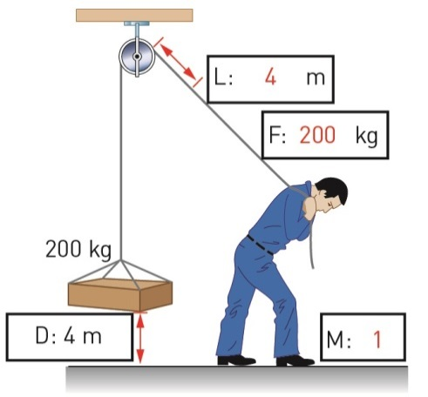

b

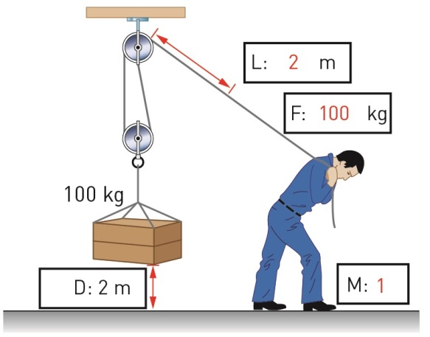

c

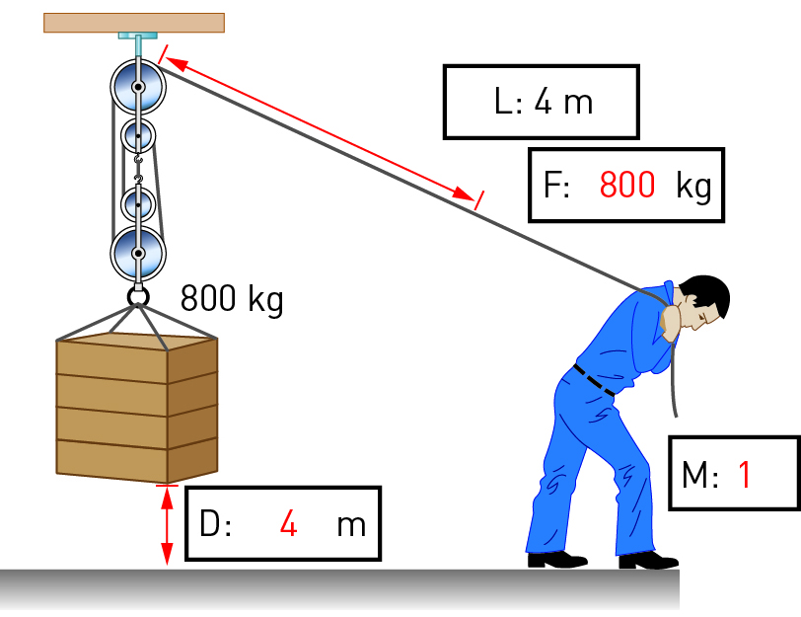

d

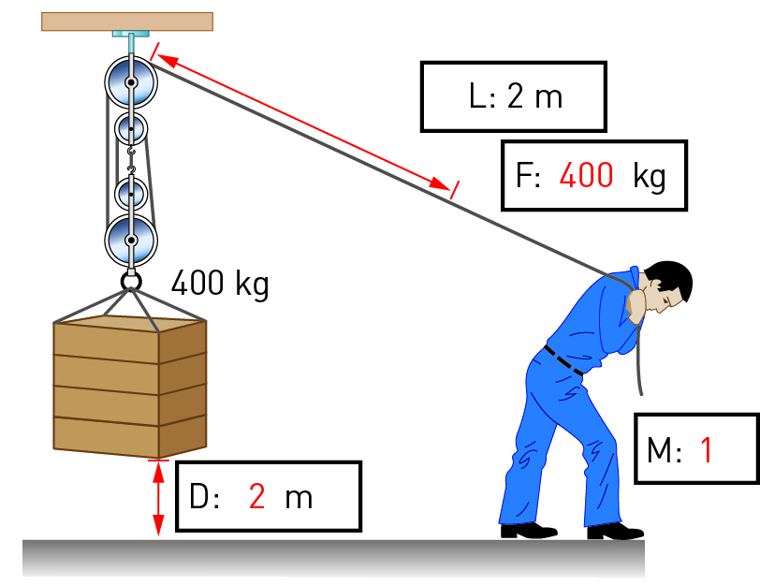

e

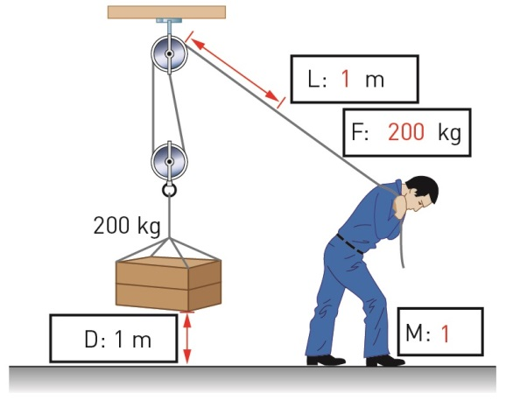

f

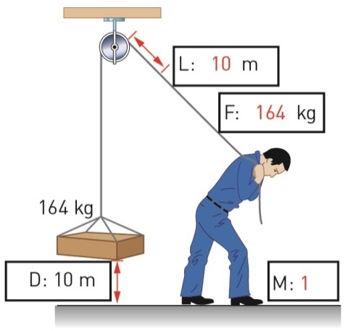

EXTEND YOUR UNDERSTANDING

2 Archimedes, the Greek scientist and mathematician who developed the pulley, also developed a machine known as Archimedes’ screw. Use the Internet to conduct research and answer the following questions:

a What was this simple machine was used for?

Archimedes’ screw is a simple machine used to pump water from a low-lying water source (such as a river or lake) up a bank to higher ground use for watering crops or for drinking.

b How does it work?

Archimedes’ screw is a wooden tube open at both ends with a spiral (or screw) running down the middle. A handle is attached to one end. When the screw turns, water is pulled up the screw from the bottom to the top.

c Is it still used today?

Archimedes’ screw is still in use in many countries around the world. For example, it is still used by farmers in Egypt to water crops. It is also used in hydro-electric power plants in the United Kingdom to move water and generate electricity.

7.9 There are different types of machines

Student worksheet answers (pages 136–137)

Types of machines

1 Look at the ramps in the two images below.

Which ramp do you think would take the least amount of effort to walk up? Explain your answer.

The ramp in the left-hand image would take the least amount of effort to walk up. The slope of the ramp in this image is less steep than the slop of the ramp in the other image.

2 Explain how your front teeth (incisors) act as a wedge when you bite into a carrot or apple.

Front teeth act as a wedge in that they are two inclined surfaces that split the food, allowing a piece to be bitten off.

3 You may have come across the saying ‘righty tighty, lefty loosey’.

a Look at the diagram of a screw being screwed into a piece of wood to explain the meaning of this saying.

As the screw is turned to the right, it is forced into the wood. Therefore, more effort is required and the screw becomes tighter. As the screw is turned to the left, it becomes looser.

b If you were turning the screw in a clockwise direction, would you be using more or less force than turning it in an anti-clockwise direction?

If you were turning the screw clockwise, the force would be greater because the spiralling ramp is forcing its way into the wood.

4

a Label the following features on the diagram:

• wheel

• axle

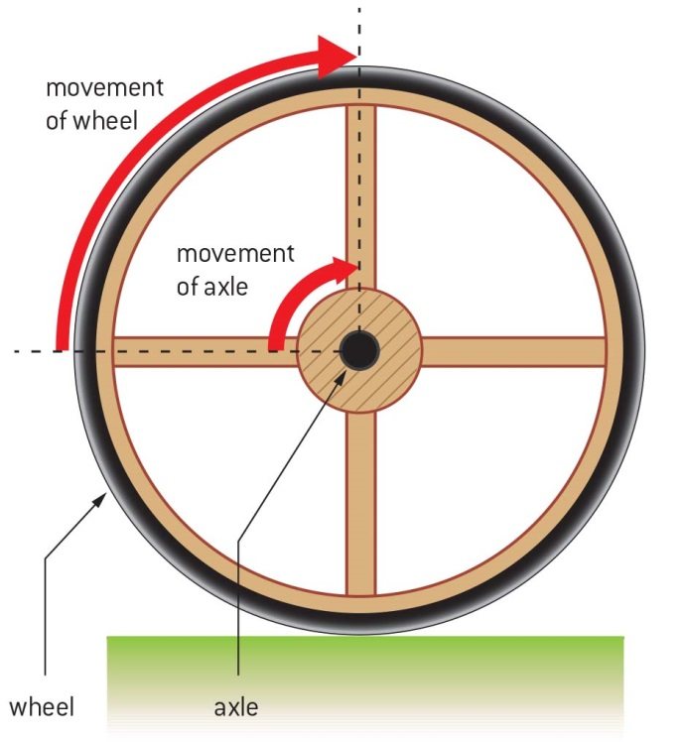

b How is this wheel a distance magnifier?

This wheel is a distance multiplier because the axle turns a small distance and the wheel turns much faster, thereby covering a larger distance.

EXTEND YOUR UNDERSTANDING

5 We are often told that cavemen invented the wheel, but this is not the case. Research which society invented the wheel. Write a 100-word summary of your findings and include how the wheel was used.

The oldest known wheel is from Mesopotamia and dates to around 3500 bce. The wheel was not initially invented for transportation purposes. Rather, it is thought that wheels were first used by potters. The wheel from Mesopotamia was a potters’ wheel, but the use of wheels for pottery making may date back even further, to the Neolithic (~9500 bce). The use of wheels for transportation is thought to have started much later, around 4500 bce.

7.10 Science as a human endeavour: Forces are involved in sport

Student worksheet answers (pages 138–139)

Forces in the body and sport

Forces in swimming

1 Why do many swimmers shave all their body hair before a competition?

The smooth skin surface allows the water to move over the swimmer’s body with less friction.

2 What is the most efficient body position for a swimmer?

A swimmer’s body is most efficient in a straight, streamlined position.

3 Describe the features of the full-body ‘smart suits’ that provided an advantage to the swimmers wearing it.

Smart suits were an advantage because the material repelled water and reduced friction between the swimmer and the water, thereby helping the swimmer to be more streamlined in the water.

Forces in tennis

4 Label the parts of the tennis player’s body that provide the fulcrum, effort and load.

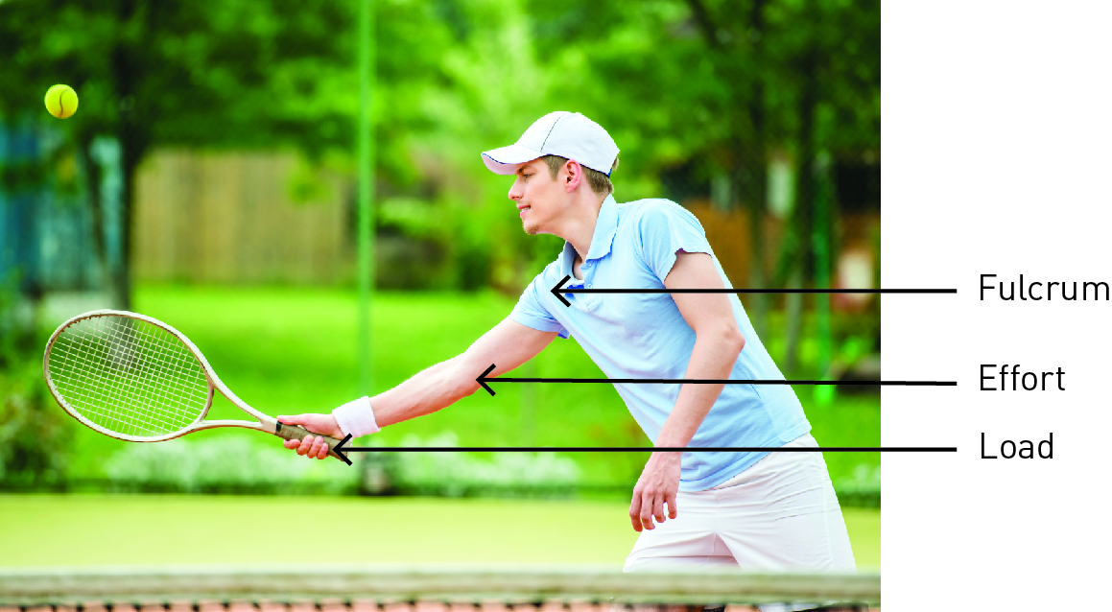

5 How do tennis racquets help produce greater speed and force?

A lighter and longer tennis racquet will increase the speed and force at which the player can hit the ball.

Forces in golf

6 Add information to the diagram below to help explain why golf balls have dimples.

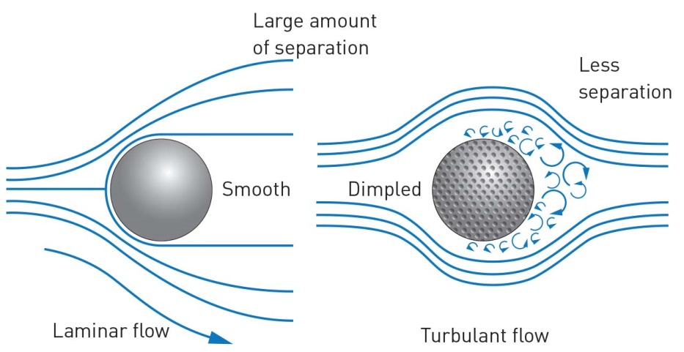

EXTEND YOUR UNDERSTANDING

7 Use the Internet to find out about kinematics. Answer the following questions:

• What is kinematics?

Kinematics is a branch of physics that studies and describes the movement of objects using words, equations, graphs and diagrams and numbers.

• Why is kinematics useful when analysing different sports?

Kinematics is really useful when analysing a range of different sports (such as football, tennis, and athletics) because it allows athletes to study the mechanics of their movements and understand them. Once they have an understanding of the mechanics of their motions, they can work to make these more efficient. For example, a tennis player can make his/her serve more efficient, fater, smoother by applying mathematical formulas from kinematics.

• What sort of technology is used to gather kinematic data?

A range of different technologies can be used to gather kinematic data. For example, when applying kinematics to the study of tennis, video footage may be gathered then imported into computer software programs that can measure the angles, speeds and forces that are being applied to the ball during a serve.

• How could kinematics be used to improve your performance when you play your favourite sport?

Student responses will vary, but may mention the following:

• Study the speed, angles and forces of balls (in ball sports like tennis, AFL, cricket, netball) to make goal scoring more effective

• Study the movement and angles of the body (in sports like ballet, cycling, rowing, running) to make movements more effective and efficient and reduce the likelihood of injuries.